Lauren Sugantino | 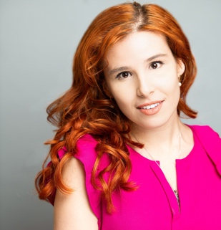  Website laurensugantino.com  Email: laurensugantin13@gmail.com  Phone: 914-471-7050
Vocal Range Soprano-Mix C3-E6
Regional Theater

Broadway Then And Now Featured Soloist Westchester Broadway Theater
Cinderella Fairy Godmother Westchester Broadway Theater
Fiddler on the Roof Ensemble/Featured Dancer Light House Youth Arts Center
The Wiz Ensemble/Featured Dancer Light House Youth Arts Center
The Wizard of OZ Wicked Witch Light House Youth Arts Center
Big River King Light House Youth Arts Center
Beauty and the Beast Madame De La Grande Bouche Light House Youth Arts Center
Les Miserables Constable/Lovely Lady Light House Youth Arts Center
Legally Blonde Delta Nu/Featured Dancer Light House Youth Arts Center
Thoroughly Modern Millie Miss Dorothy Light House Youth Arts Center
High School Musical Cyndra/Ensemble Yorktown Stage Theater
Bye bye, birdie Kim MacAfee Artistree/Emblem Theater
The Wizard of OZ Ensemble/Dancer Yorktown Stage Theater
Matilda Acrobat/Dancer Yorktown Stage Theater
GUYS AND DOLLS HOT BOX GIRL/DANCER Artistree/Emblem Theater
MARY POPPINS MRS. COREY/DANCER Yorktown Stage Theater
Skills

British Accent Choir (8 years) Piano
Southern Accent Acting Jazz (Dance)
Sings German and Italian Advanced sight-reading abilities. Modern and Tap dancing (intermediate)

Accomplishments

NYSMA-All-State Choir First Soprano
Outstanding Effort-Choral Music Award
CS Music- Certified Artist Award 2021-2022

Vocal Training
Amadeus Conservatory of Music, Irena Portenko
Private Voice: Opera/Musical Voice (Present), Julia Vaara

Dance Training
- Light House Youth Arts Center - David Arzberger
- Light House Youth Arts Center - Jesse Pellegrino

